VM Instances Self-service Force Restart Guide
Because of the high usage of CPU or RAM, the VMs will crash sometimes and users could do nothing by themselves. Now I will introduce the method to force restart your VM by yourself.
- Login the URL: https://vmss.ebaotech.com , then input your account and password as below.（web browser: chrome）
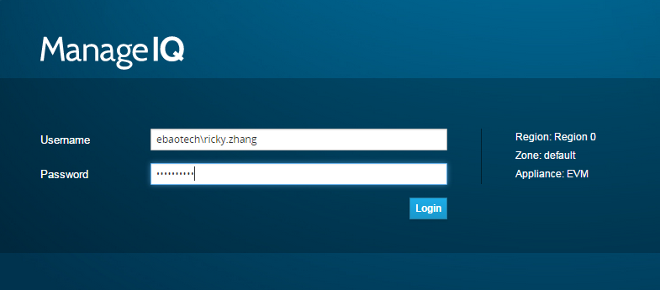

- When you login successfully, you will find the webpage as below.
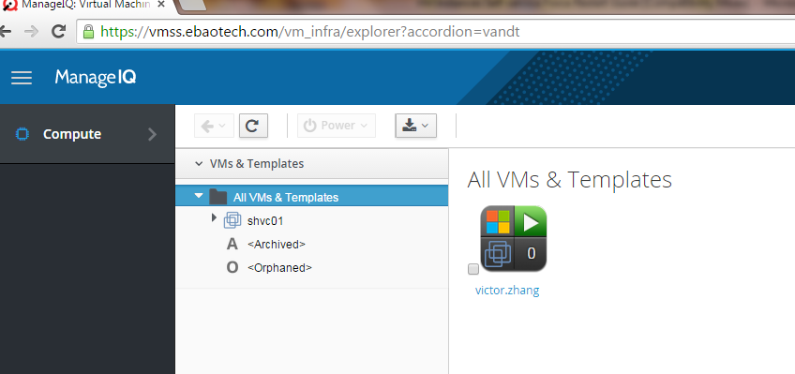

- Choose your vm and then choose “reset” to restart your vm.
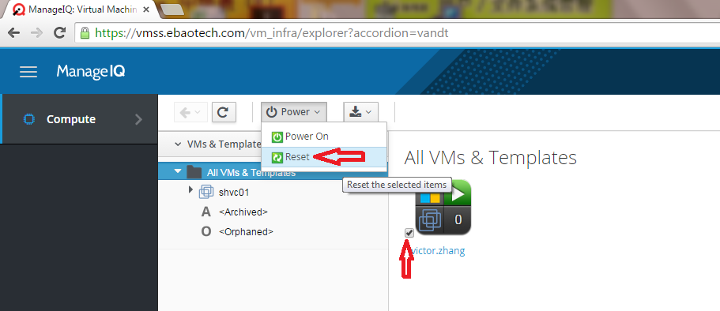
- Wait about 5mins, then try to login again.

